|  |  |
| --- | --- |
| **NAME:** | **TEACHER:** |

**Level 1 Mathematics and Statistics**

**2012**

|  |
| --- |
| **91267 Apply probability methods in solving problems** |

# Credits: Four

**You should answer ALL parts of ALL the questions in this booklet.**

You should show ALL your working for ALL questions.

The questions in this booklet are NOT in order of difficulty.

If you need more space for any answer, use the page(s) provided at the back of this booklet and clearly number the question.

**YOU MUST HAND THIS BOOKLET TO YOUR TEACHER AT THE**

**END OF THE EXAMINATION.**

|  |  |  |
| --- | --- | --- |
| **For Assessor’s use only Achievement Criteria** | | |
| **Achievement** | Achievement **with Merit** | **Achievement**  **with Excellence** |
| Apply probability methods in solving problems. | Apply probability methods, using relational thinking, in solving problems. | Apply probability methods, using extended abstract thinking, in solving problems. |
| Overall Level of Performance | | |

You are advised to spend 60 minutes answering the questions in this booklet.

Assessor’s

use only

**QUESTION ONE**

(a) The weights of two year old salmon on Sammy’s Salmon farm are normally distributed

with mean weight of 1.8 kg and a standard deviation of 0.25 kg.

Use this model to answer the questions below.

(i) What is the probability that a two year old salmon, chosen at random from Sammy’s

farm, weighs between 1.8 kg and 2 kg?

_________________________________________________________________________

_________________________________________________________________________

(ii) What percentage of two year old salmon would Sammy expect to weigh more than

2.1 kg?

_________________________________________________________________________

_________________________________________________________________________

(iii) Sammy does not sell any salmon under 1.1 kg as he doesn’t think they are big enough. Sammy has 25 000 two year old salmon this year. How many of them will he not sell

because they are not big enough?

_________________________________________________________________________

_________________________________________________________________________

_________________________________________________________________________

(iv) What weight do 80% of two year old salmon exceed?

_________________________________________________________________________

_________________________________________________________________________

_________________________________________________________________________

(v) What is the **range** of weights for the central 80% of two year old salmon?

_________________________________________________________________________

_________________________________________________________________________

_________________________________________________________________________

_________________________________________________________________________

_________________________________________________________________________

(b) Sharon and Simon also have salmon farms.

Sharon records the weights of her 34 different two year old salmon on the histogram below

Assessor’s

use only

at the top of the page.

Simon records the weights of his 126 different two year old salmon on the histogram below

at the bottom of the page.

You can use this information to answer the questions on the facing page.

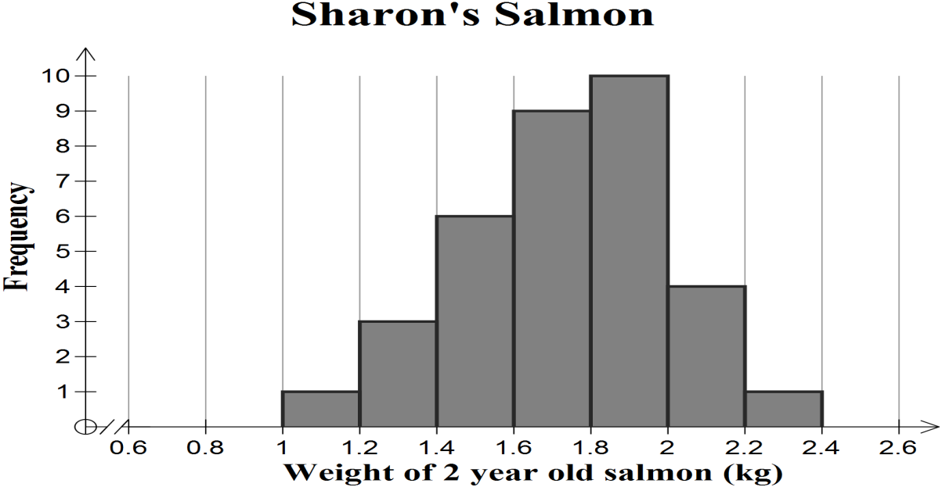

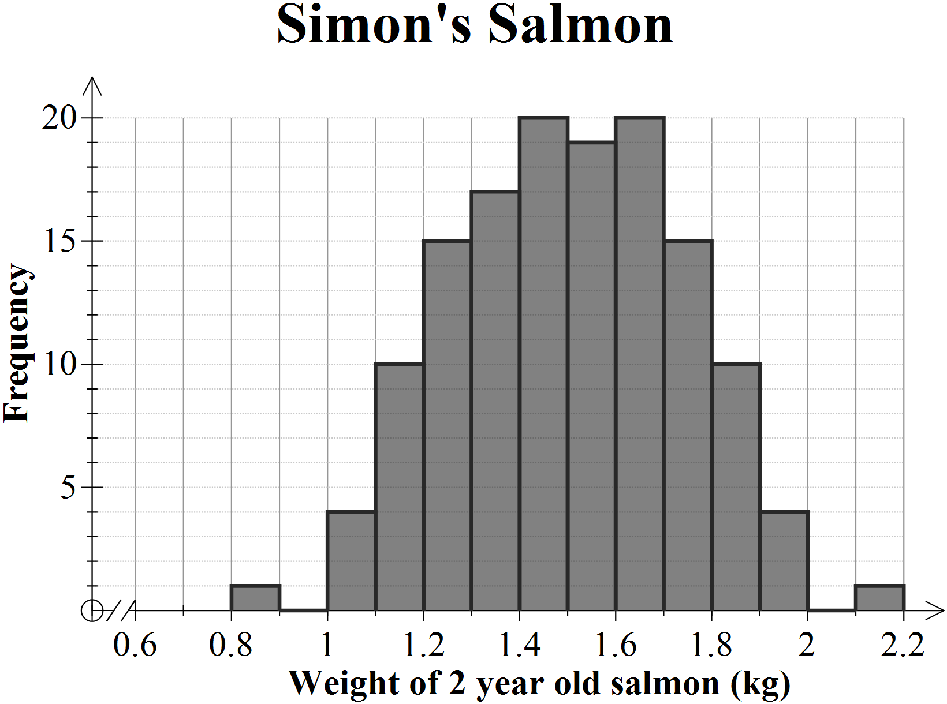

(i) What proportion of Sharon’s salmon weigh more than 2 kg?

_________________________________________________________________________

Assessor’s

use only

_________________________________________________________________________

_________________________________________________________________________

(ii) Sharon thinks that the weights of her salmon are normally distributed.

Is she justified in thinking this? Use statistical terms to explain your answer.

_________________________________________________________________________

_________________________________________________________________________

_________________________________________________________________________

_________________________________________________________________________

(iii) Compare the distribution of weights of two year old salmon from Sharon with the

distribution of weights of 2 year old salmon from Simon.

Use statistical terms to explain your answer.

_________________________________________________________________________

_________________________________________________________________________

_________________________________________________________________________

_________________________________________________________________________

_________________________________________________________________________

_________________________________________________________________________

_________________________________________________________________________

_________________________________________________________________________

_________________________________________________________________________

_________________________________________________________________________

_________________________________________________________________________

_________________________________________________________________________

_________________________________________________________________________

_________________________________________________________________________

**QUESTION TWO**

(a) People with high blood pressure were treated in a trial with either a new drug called BP1

Assessor’s

use only

or a placebo (it looked the same as BP1 but had no contents to affect blood pressure).

The table shows the number of people treated with each and whether their high blood

pressure improved or not.

|  |  |  |  |
| --- | --- | --- | --- |
| **Treatment** | **Blood pressure improved** | **Blood pressure didn’t improve** | **Total people treated** |
| **BP1** | 231 | 144 | **375** |
| **Placebo** | 191 | 120 | **311** |
| **Total** | **422** | **264** | **686** |

(i) What proportion of the people in the trial given either BP1 or the placebo had their

blood pressure improve?

_________________________________________________________________________

_________________________________________________________________________

(ii) What percentage of the people in the trial, whose blood pressure improved, were

given BP1?

_________________________________________________________________________

_________________________________________________________________________

(iii) What proportion of people in the trial had their blood pressure not improve and

were given the placebo?

_________________________________________________________________________

_________________________________________________________________________

_________________________________________________________________________

(iv) If another study was done with 5000 people using BP1 how many would you expect

to have their blood pressure improve?

_________________________________________________________________________

_________________________________________________________________________

_________________________________________________________________________

(v) A newspaper headline stated that “**By using the new drug BP1 a person was more**

Assessor’s

use only

**likely to have their blood pressure improve, compared to using a placebo”**.

State, with reasons and any relevant calculations, whether you agree with this headline.

_________________________________________________________________________

_________________________________________________________________________

_________________________________________________________________________

_________________________________________________________________________

_________________________________________________________________________

_________________________________________________________________________

(b) Of the 686 people treated in the trial 424 were over 60 years old. Of these 424 people 259

had their blood pressure improve. 194 of these 424 people were given the placebo and of

these 94 had their blood pressure improve.

(i) What is the probability that an over 60 year old, given a placebo, did not have their

blood pressure improve? The table below may help.

|  |  |  |  |
| --- | --- | --- | --- |
|  | **Blood pressure improved** | **Blood pressure didn’t improve** | **Total** |
| **BP1** |  |  |  |
| **Placebo** |  |  |  |
| **Total** |  |  |  |

_________________________________________________________________________

_________________________________________________________________________

(ii) The company producing BP1 claimed that the relative risk of blood pressure

improving was 1.5 for an over 60 year old using BP1 compared to an over 60 year old

using a placebo.

Give statistical reasons, supported by calculations, whether you agree with this claim.

_________________________________________________________________________

_________________________________________________________________________

_________________________________________________________________________

_________________________________________________________________________

_________________________________________________________________________

_________________________________________________________________________

_________________________________________________________________________**QUESTION THREE**

Assessor’s

use only

FOOD4ALL has two machines, A and B, making packets of chips.

The machines run continuously when the factory is working.

Jenni, Kate and Murray work on both machine A and machine B.

Machine B produces 35% of the packets of chips.

Some of this information is illustrated below on the probability tree.

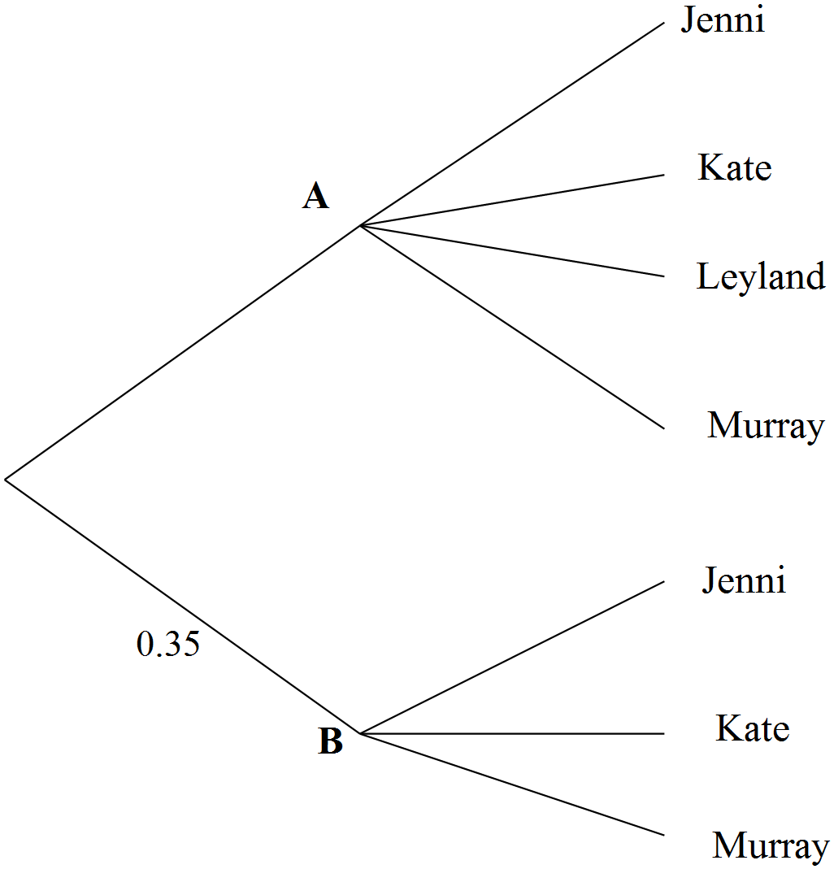

(a) What is the probability that a packet of chips selected at random came from machine A?

_________________________________________________________________________

_________________________________________________________________________

(b) Jenni produces 64% of packets of the packets of chips from machine B.

Kate and Murray produce equal amounts of packets of chips on machine B.

(i) What is the probability that a randomly selected packet of chips is produced by Murray

on machine B?

_________________________________________________________________________

_________________________________________________________________________

_________________________________________________________________________

_________________________________________________________________________

(ii) Leyland works only on machine A, but he produces 44% of the packets of chips

Assessor’s

use only

produced on this machine.

Jenni and Kate produce ¼ each of the rest and Murray produces the remainder.

What is the probability that a packet of chips selected at random was produced by

Murray on machine A?

_________________________________________________________________________

_________________________________________________________________________

(iii) If FOOD4ALL produced 55 000 packets of chips in a day, how many packets would

Murray produce?

_________________________________________________________________________

_________________________________________________________________________

_________________________________________________________________________

(c) The probability that a packet Jenni produces on machine B is faulty (has to be rejected)

is 0.01 and the probability that anyone makes a faulty packet on machine A is 3 in 1000.

(i) A packet of chips that Jenni produced is found to be faulty.

What is the probability that it came from machine A?

_________________________________________________________________________

_________________________________________________________________________

_________________________________________________________________________

_________________________________________________________________________

_________________________________________________________________________

_________________________________________________________________________

(ii) A packet of chips made on machine A is faulty.

What is the probability it was produced by Leyland?

Assessor’s

use only

_________________________________________________________________________

_________________________________________________________________________

_________________________________________________________________________

_________________________________________________________________________

_________________________________________________________________________

_________________________________________________________________________

(iii) On 14th September 0.6% of the 60,000 packets of chips FOOD4ALL produced were

found to be faulty.

74 of these had been produced by Leyland.

What percentage of the packets of chips Leyland produced on the 14th September

were faulty?

Compare this result with the overall production of faulty packets of chips.

_________________________________________________________________________

_________________________________________________________________________

_________________________________________________________________________

_________________________________________________________________________

_________________________________________________________________________

_________________________________________________________________________

_________________________________________________________________________

_________________________________________________________________________

_________________________________________________________________________

_________________________________________________________________________

_________________________________________________________________________

_________________________________________________________________________

|  |
| --- |
| **Extra paper for continuing your answers, if required.**  Assessor’s  use only  **Clearly number the question(s).** |

**Question**

**Number**

_________________________________________________________________________

_________________________________________________________________________

_________________________________________________________________________

_________________________________________________________________________

_________________________________________________________________________

_________________________________________________________________________

_________________________________________________________________________

_________________________________________________________________________

_________________________________________________________________________

_________________________________________________________________________

_________________________________________________________________________

_________________________________________________________________________

_________________________________________________________________________

_________________________________________________________________________

_________________________________________________________________________

_________________________________________________________________________

_________________________________________________________________________

_________________________________________________________________________

_________________________________________________________________________

_________________________________________________________________________

_________________________________________________________________________

_________________________________________________________________________

_________________________________________________________________________

**ASSESSMENT SCHEDULE**

#### **91267 Apply probability methods in solving problems**

|  |  |  |
| --- | --- | --- |
| **Achievement** | **Achievement with Merit** | **Achievement with Excellence** |
| *Apply probability methods in solving problems* involves*:*  • selecting and using methods  • demonstrating knowledge of  probability concepts and terms  • communicating using appropriate  representations.  . | *Apply probability methods, using relational thinking, in solving problems* involves one or more of:  • selecting and carrying out a logical  sequence of steps  • connecting different concepts or  representations  • demonstrating understanding of concepts;  and also relating findings to a context, or  communicating thinking using appropriate mathematical statements. | *Apply probability methods, using extended abstract thinking, in solving problems* involves one or more of:  • devising a strategy to investigate or solve  a problem  • identifying relevant concepts in context  • developing a chain of logical reasoning  • making a statistical generalisation;  and also, where appropriate, using contextual knowledge to reflect on the answer. |

Sufficiency for each question:

N0: no relevant evidence

N1: Attempt at one question

N2: 1 **u**

A3: 2 **u**

A4: 3 **u**

M5: 1 **r**

M6: 2 **r**

E7: 1 **t**

E8: 2 **t**

**Judgement Statement**

NOTE: This is an estimate as no examinations have yet been held.

|  |  |  |  |  |
| --- | --- | --- | --- | --- |
|  | **Not Achieved** | **Achievement** | **Achievement with Merit** | **Achievement with Excellence** |
| **Score range** | 0 - 8 | 9 - 13 | 14 - 17 | 18 -24 |

| Question One | Evidence | Achievement (u) | Merit (r) | Excellence (t) |
| --- | --- | --- | --- | --- |
|  |  | **Apply probability methods in solving problems.** | *Apply probability methods, using relational thinking, in solving problems.* | *Apply probability methods, using extended abstract thinking, in solving problems.* |
| 1a(i) | 0 < *z* < 0.8  Probability = 0.28814 | Correct probability calculated. |  |  |
| 1a(ii) | *z* > 1.2  Probability = 0.11506  11.5 percent | Correct probability calculated and answer written as percentage. |  |  |
| 1a(iii) | *z* < - 2.8  Probability = 0.0025551  Expected number 63 (or 64) | Correct probability calculated. | Expected number calculated. |  |
| 1a(iv) | *z* = - 0.842  1.5895 kg | Inverse normal value of z found. | Correct weight calculated. |  |
| 1a(v) | 40% either side of mean  ie *z* =  Between 1.4796 kg and 2.1203 kg  ie range = 0.6407 kg | Inverse normal value of z found. | Limits of weights found. | Correct range specified. |
| 1b(i) |  |  |  |  |
| 1b(ii) | Probably not justified.  The distribution looks left skewed.  The distribution is not symmetrical.  The median is not central (4 groups to the left and 2 to the right of median group).  The mean is not central.  Small sample | Statement with one correct reason to support this statement. | Statement with incomplete justification. | Statement completely and correctly justified. |
| 1b(iii) | Curve looks approximately normal as it is quite symmetrical about the central values unlike Sharons.  Mean of Simon’s is smaller (1.5 cf 1.7).  Median of Simon’s smaller (1.5-1.6 cf 1.6-1.8)  SD of Simon’s seems smaller (actually 0.23 cf 0.27 but students cannot quote this. | Two correct and relevant statements. | A complete explanation given. |  |

**NOTE:**

There will be differences between probability answers quoted if students use normal distribution tables rather than GC. Either should be accepted.

Values given here are all GC values

| Question TWO | Evidence | Achievement (u) | Merit (r) | Excellence (t) |
| --- | --- | --- | --- | --- |
|  |  | **Apply probability methods in solving problems.** | *Apply probability methods, using relational thinking, in solving problems.* | *Apply probability methods, using extended abstract thinking, in solving problems.* |
| 2a(i) | [  0.615] | Correct probability calculated. |  |  |
| 2a(ii) | [  0.547] = 54.7% | Correct probability calculated. | Correct percentage calculated. |  |
| 2a(iii) | [  0.175] | Correct probability calculated. |  |  |
| 2a(iv) | = 3080 | Correct probability calculated. | Expected number calculated. |  |
| 2a(v) | Using BP1:  0.616 have improved blood pressure.  Using placebo :  0.614 have improved blood pressure.  I disagree with this headline as there is almost no difference taking a placebo and taking BP1.  OR  I agree with this headline BUT there is almost no difference taking or not taking BP1 and this should be implied in the headline. |  | Comparison made between BP1 and placebo. | Correct conclusion AND supported by calculations. |
| 2b(i) | |  |  |  |  | | --- | --- | --- | --- | |  | **B press imp** | **B pres**  **not imp** | **Total** | | **BP1** | 165 | 65 | 230 | | **Pla** | 94 | 100 | 194 | | **Tot** | 259 | 165 | 424 |   Prob required =  0.515 | Correct table or numbers calculated. | Correct probability calculated. |  |
| 2b(ii) | Prob blood pressure of an over 60 year old improving using BP1 =  0.717  Prob blood pressure of an over 60 year old improving using placebo = 0.485    So relative risk of blood pressure improving using PB1 is 1.47 so company claim is correct. | A correct probability calculated. | Both correct probabilities calculated. | Probabilities correctly compared and a justified statement made. |

| Question Three | Evidence | Achievement (u) | Merit (r) | Excellence (t) |
| --- | --- | --- | --- | --- |
|  |  | **Apply probability methods in solving problems.** | *Apply probability methods, using relational thinking, in solving problems.* | *Apply probability methods, using extended abstract thinking, in solving problems.* |
| 3a | 0.65 | Correct probability calculated. |  |  |
| 3b(i) |  | Correct probability calculated. |  |  |
| 3b(ii) |  | Correct probability calculated. |  |  |
| 3b(iii) | Prob =  Expected number  = | Correct probability calculated. | Expected number calculated. |  |
| 3c(i) | P (faulty from B) =  = 0.00224  P (faulty from A) =  = 0.000273  Reqd prob =  = 0.109 | Correct probability calculated for a faulty part. | Total probability calculated for a faulty part. | Correct probability calculated. |
| 3c(ii) | 0.44 |  | Correct probability calculated. |  |
| 3c(iii) | Leyland produced  of all packets  Number of packets Leyland produced  =  Prob Leyland has faulty packet  =  ie Leyland’s % of faulty packets is 0.43%  This compares with overall faulty rate of 0.6% so he is much better. | Correct probability calculated. | Correct probability found for Leyland producing a faulty packet. | Correct percentage found AND a sensible comparison made |