Hotel Prices
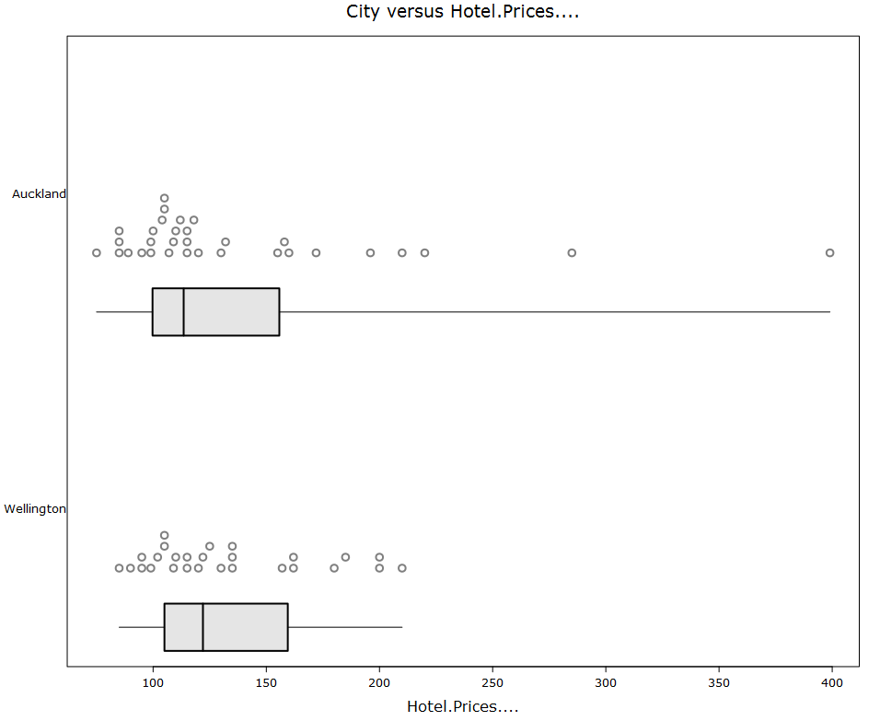

Summary of Hotel.Prices.... by City:

Min. 1st Qu. Median Mean 3rd Qu. Max. Std.dev Sample.Size n.missing
Auckland 75 99.75 113.5 136.4 155.8 399 66.6 32 0
Wellington 85 105 122 132.7 159.5 210 36.7 27 0

