

Iona College

Name:________________________________ Teacher:_____________________

2

|  |
| --- |
| Level 2 Mathematics and Statistics  Mid Year Assessment 2014  91267 (2.12): Apply probability methods in solving problems  Credits: Four |

You should answer ALL parts of ALL questions in this booklet.

You should show ALL your working.

If you need more space for any answer, use the page(s) provided at the back of this booklet and clearly number the question.

Check that this booklet has pages 2–12 in the correct order and that none of these pages is blank.

YOU MUST HAND THIS BOOKLET TO YOUR TEACHER AT THE END OF THE ALLOTTED TIME.

Total

**Attendance and Absence**

You are advised to spend 60 minutes answering the questions in this booklet.

Question one:

1. Maddy the mathematics teacher notices that the attendance of her students varies.

She finds that the students attendance is normally distributed with a mean of 140 days

and a standard deviation of 12.5 days per year.

Use this model to answer the following questions.

What is the probability that a randomly selected student will attend school between 140 and 160 days?

What percentage of student attended for more than 160 days?

Students who attend less than 125 days are monitored and interviewed with their parents.

Of the 845 students at this school how many would have been interviewed.

The school year is 180 days. What is the smallest number of days a student could attend school for and still be in the top attending 10% of all students?

What is the range of days was attended by the central 75% of students?

1. Maddy found the attendance chart for students in the school the previous year.

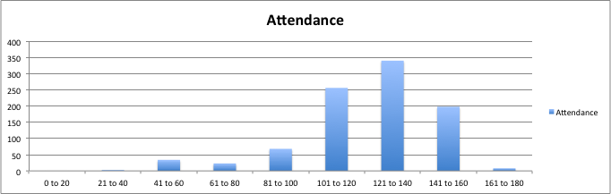

Number of days present.

Number of students.

1. Estimate the proportion of students who attended for less than 100 days.
2. Is Maddy justified in thinking that students in this attendance chart are normally distributed.

Use statistical terms to explain your answer.

(iii) Maddy compared this chart with the most recent one shown below.

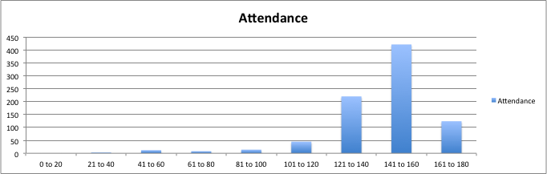

Compare the attendance of students for both years shown.

Use statistical terms to explain your answer.

Question two:

1. Maddy the mathematics teacher noticed that some students in the Probability Maths 2.6 course had good attendance and yet were unsuccessful and some other students had poor attendance but were successful.

Maddy put the data she had collected into a table.

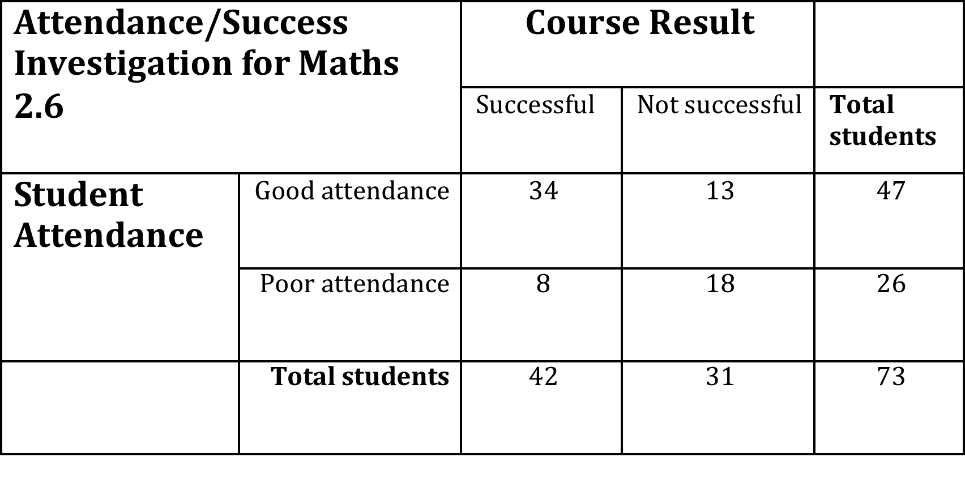

1. What proportion of students were successful?
2. What percentage of students with good attendance were successful?
3. Maddy is showing the results to her 2013 year students advising them that they will be more likely to be successful if they have good attendance.

What is the risk of a student with poor attendance being unsuccessful?

1. What is the relative risk of a student with poor attendance being unsuccessful when compared to a student with good attendance? Show all working and interpret the result.
2. If there were 250 students taking this course with the same attendance habits how many students with poor attendance could be expected to be successful?
3. During term 2 Maddy recorded the absences for her class of 15 boys and 9 girls for each day of the school week.

She noticed that the attendance varied on different days of the week.

Her class had maths every day. There were 9 weeks in term 2.

|  |  |  |
| --- | --- | --- |
|  | Total number of absences for the term on each week day of the term. | |
| Class | Boys | Girls |
| Mon AM | 32 | 16 |
| Tue AM | 18 | 8 |
| Wed PM | 11 | 12 |
| Thu AM | 14 | 7 |
| Fri Pm | 36 | 19 |

1. What is the probability that a student was absent on Monday?
2. What was the relative risk of absence for boys compared to girls in this class during Term 2?

Question three:

Maddy noticed the girls in the class and boys in the class had different attendance habits. She had 9 girls and 15 boys and Maddy had this class every day.

She used the school absence system and found out that boys had a 35% chance of being absent from class and girls had a 40% chance of being absent on any one day. Some of this information is shown on the diagram below.

$\frac{15}{24}$ Boys

35% Absent

(i) What is the probability of a randomly chosen student being a boy and being absent?

(ii) What is the probability of a randomly chosen student being a girl and being present? Compare your answer with a(i) and make a comment.

1. A student who is present randomly chosen to welcome a visitor to the class.

What is the probability of the student who is chosen being of being a boy?

(iv) How many students could Maddy expect to turn up to class each day?

1. Maddy decided to give the students who turned up in class a toffee as a reward. This intervention reduced the absence rate for the girls by 90% and for the boys by 60%.
2. - What is now the probability of a girl being absent?

* Describe the attendance of girls in the class and how the reward scheme affected the attendance.

1. How many more students did Maddy now expect every day in her class?

ASSESSMENT SCHEDULE • ATTENDANCE and ABSENCE

Mathematics and Statistics 91267 (2.12): Apply probability methods in solving problems

Achievement criteria

|  |  |  |
| --- | --- | --- |
| Achievement | Achievement with Merit | Achievement with Excellence |
| *Apply probability methods in solving problems* must involve using a range of appropriate methods, demonstrating knowledge of probability concepts and terms, and communicating using appropriate representations. | *Apply probability methods, using relational thinking, in solving problems* must involve one or more of:   * selecting and carrying out a logical sequence of steps * connecting different concepts or representations * demonstrating understanding of concepts * and relating findings to a context or communicating thinking using appropriate statements. | *Apply probability methods, using extended abstract thinking, in solving problems* must involve one or more of:   * devising a strategy to investigate or solve a problem * identifying relevant concepts in context * developing a chain of logical reasoning * and where appropriate, using contextual knowledge to reflect on the answer. |

Evidence Statement

|  |  |  |  |  |
| --- | --- | --- | --- | --- |
| Q ONE | Expected Coverage | Achievement | Merit | Excellence |
| NØ = No response; no relevant evidence.  N1 = a valid attempt at ONE question.  N2 = ONE question demonstrating limited knowledge (1u)  A3 = TWO of u.  A4 = THREE of u.  M5 = ONE of r.  M6 = TWO of r.  E7 = ONE of t, with minor errors ignored.  E8 = 2 of t | | | | |
| (a) (i) | Z = 1.6  Probability = 0.4452 | Probability found  u |  |  |
| (a) (ii) | Z = 1.6  Probability = 0.5 - 0.4452  = 0.0548  = 5.48% | Probability found or recognised and used from previous example  u |  |  |
| (a) (iii) | Z = -1.2  Probability = 0.5 - 0.3849  = 0.1151  Expected # = 845x0.1151  =97 (or 98) | Probability found  u | Expected number calculated  r |  |
| (a) (iv) | Inverse Z for probability of 0.4 found.  Z = 1.281  Days = 156 | Inverse normal value of z found  u | Days calculated  r |  |
| (a) (v) | Central 75% is probability of 0.375 either side of the mean giving a z score of 1.281  x =154  Range = 126 to 154 days | Inverse normal value of z found  u | x calculated  r | Range specified  t |
| (b) (i) | Proportion = 120/920 = 0.13  Both 120 and 920 are readings so accept sensible estimates. | Proportion found  u |  |  |
| (b) (ii) | Curve is approximately bell shaped.  Skewed left (bulk right) slightly but 180 limits the top cut off  Centre value about 130  Is justified in thinking weights are normally distributed. | A correct and relevant statement.  u | A complete explanation given  r |  |
| (b) (iii) | Both normal or bell shaped and both slightly skewed left.  Right limited by 180 day limit.  Mean is central to shape.  Mean in recent one higher 140 than older 130.  More spread in older. | Statement and a correct reason to support this statement  u | Statement and incomplete justification  r | More than 2 correct statements, justified reasoning  t |

|  |  |  |  |  |  |  |
| --- | --- | --- | --- | --- | --- | --- |
| Q TWO | Expected Coverage | | Achievement | Merit | | Excellence |
| NØ = No response; no relevant evidence.  N1 = a valid attempt at ONE question.  N2 = ONE question demonstrating limited knowledge (1u)  A3 = TWO of u.  A4 = THREE of u.  M5 = ONE of r.  M6 = TWO of r.  E7 = ONE of t, with minor errors ignored.  E8 = 2 of t | | | | | | |
| (a) (i) | 42/73 = 0.575 | Proportion calculated.  u | |  |  | |
| (a) (ii) | 34/47 = 0.723 = 72.3%  accept any rounding | Percentage calculated.  u | |  |  | |
| (a)(iii) | Risk = 18/26 = .692 | Risk (or probability) calculated.  u | |  |  | |
| (a) (iv) | Risk for good student of being unsuccessful  =13/47 = .277  Relative risk is (from (iii))  =.692/.277 = 2.50 (3sf)  This means a student with poor attendance has 2.5 times the chance of being unsuccessful at school. [A poor attending student has 250% more likelihood of failing]. {150% more, note language used} | Risk calculated for good student being unsuccessful.  u | | Relative risk calculated  r | Clear interpretation of correct relative risk.  t | |
| (a) (v) | Expected number  = 8/26 x 250  =77 students. |  | | Expected number calculated.  r |  | |
| (b) (i) | Number of possible absences = 15x9 +9x9  = 216  Actual absences = 32+16  Prob = 48/216= 0.22 |  | | Probability correct  r |  | |
| (b) (ii) | Risk of absence  in T2 for boys  = Total/possible  = 111/675 = 0.164  For girls = 62/405 =0.153  So relative risk is  =0.164/0.153 = 1.07  or much the same. The boys and the girls have similar absence rates or behaviour. |  | | Risks and relative risk calculated but not interpreted correctly.  r | Correct interpretation stated clearly.  t | |

|  |  |  |  |  |  |  |  |
| --- | --- | --- | --- | --- | --- | --- | --- |
| Q Three | Expected Coverage | Achievement | | Merit | | Excellence | |
| NØ = No response; no relevant evidence.  N1 = a valid attempt at ONE question.  N2 = ONE question demonstrating limited knowledge (1u)  A3 = TWO of u.  A4 = THREE of u.  M5 = ONE of r.  M6 = TWO of r.  E7 = ONE of t, with minor errors ignored.  E8 = 2 of t | | | | | | |
| (a) (i) | Prob = 15/24x 0.35  =0.219 | | Probability calculated  u |  |  | |
| (a) (ii) | Prob = 9/24x0.6  = 0.225  The probability of a boy being absent is about the same as the probability that a girl is present. | | Probability calculated  u |  | Sensible and relevant comment.  t | |
| (a) (iii) | P(A student being present)  = 15/24 x .65 +9/24 x .60  = 0.63125  P(of a boy being present and being chosen)  = (15/24 x 0.65)  = 0.40625  Probability that of the students who are present a boy being chosen)  = 0.40625/0.63125  0.644 | |  | Combined probability calculated.  r |  | |
| (a) (iv) | 15 x 0.65 +9 x 0.60  = 15.4 students  Accept 15 or 16. | |  | Expected number calculated.  r |  | |
| (b) (i) | New absence rate for the girls is 0.40 x (1-.9)  =0.04 or very small.  All of the girls are almost always in class. 9x0.04 = .36 so every three days 1 girl can be expected to be absent. | | New rate calculated  u | New rate calculated and explained.  r |  | |
| (b)(ii) | Absence rate for boys is now 0.35x.6=.21  E(boys absent) = .21 x 15  = 3.15  E(girls absent) = .04 x 9  = 0.36 as above.  Total absent = 3.5 students  So Maddy can expect  24-3.5 students or either 20 or 21 students every day in class.  Answer is 4, 5 or 6 more students depending on answer in a(iv). | | New rate for boys calculated  u | Expected number combined.  r | Increase more correctly calculated and explained.  t | |