NAME: | TEACHER:

YEAR 10 MATHEMATICS

2014 END OF YEAR EXAM

Algebra

Answer ALL questions in the spaces provided in this booklet. Show ALL working.

For Assessor’s use only
Curriculum Level

==========================================================================
SKILLS QUESTIONS
The NCEA assessment for this topic is an examination, so no extra “NCEA Style” section is included.

QUESTION ONE
The first two sets of scales are balanced. The third set of scales needs objects added to the right-hand side.

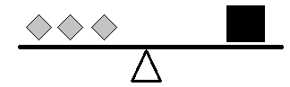
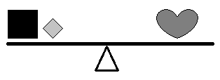
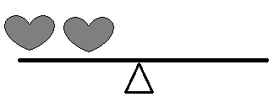
In the boxes below, give two different examples of what could be placed on the right hand side of the third set of scales to balance them. Do not repeat the left-hand side.

Option 1

Option 2

QUESTION TWO

What number is missing in these equations?

  - 14 + 8 = 31 –

  - 36 + 32 = + 5

QUESTION THREE

Here are some algebraic equations. Solve each one to find the value of n. Show all your working.

- 15 + n = 32

_______________________________________

_______________________________________

- 4n + 3 = 47

_______________________________________

_______________________________________

- 6n – 2 = 19

_______________________________________

_______________________________________

- 4(n + 1) = 48

_______________________________________

_______________________________________

_______________________________________

- 5n + 3 = 2n + 15

_______________________________________

_______________________________________

_______________________________________

_______________________________________

QUESTION FOUR

For the problems in the next column, find the solution by writing and solving an algebraic equation. Show all of your working.
- Jill, Phil and Bill all read books at silent reading time. Jill gets 36 pages read. Bill reads twice as many pages as Phil. The three students read 117 pages altogether. How many pages did Phil read?

_______________________________________

_______________________________________

_______________________________________

_______________________________________

- A rectangle is 2 cm longer than it is wide. Its perimeter is 32 cm. What are the dimensions of the rectangle?

_______________________________________

_______________________________________

_______________________________________

_______________________________________

- Two towns are 52 km apart. Buses travelling between the two towns leave at the same time but travel in opposite directions. The bus from town A is travelling 80 km/h and the bus from town B is travelling 70 km/h. How long after they leave will they pass each other? (Reminder: there are 60 minutes in an hour!)

_______________________________________

_______________________________________

_______________________________________

QUESTION FIVE
In rugby, a team’s score (S) is given by:

S = 5T + 2C + 3G

Where T = the number of tries, C = the number of conversions after tries and G = the number of other successful conversions (drop goals and penalties.)

- In a game, a team scored 4 tries, converted two of them and also got points from 2 penalty kicks. Calculate their score.

_______________________________________

_______________________________________

_______________________________________

- Another team scored 22 points. They only had one successful penalty kick and no drop goals.
- If two of their tries were converted, calculate how many tries they scored altogether.

_______________________________________

_______________________________________

- Write a formula using S, C, T, G to show how the number of tries (T) can be calculated from the other variables.

_______________________________________

_______________________________________

_______________________________________

QUESTION SIX

Simplify the following expressions:

- p + p + p = ___________

- e x e x e x e x e = ___________

- 5 x 4n = ___________
- 6y – 4r + 3y + r = ___________________

- 5b x 4a x 3b = ___________

QUESTION SEVEN

- Expand (and simplify where appropriate)
- 4(p + q)

_______________________________________

- n(3n + 6)

_______________________________________

- 4y( 8 – y)

_______________________________________

- 5(n + 3) + 2(n + 4)

_______________________________________

_______________________________________

- (n + 5)(n + 3)

_______________________________________

_______________________________________

- Factorise these expressions

- 6f – f²

_______________________________________

- 10y – 15

_______________________________________

- 14g² – 21g³

_______________________________________

- x² + 8x + 12

_______________________________________

_______________________________________

QUESTION EIGHT

A room needs new skirting board applied. It will be applied to all walls except for a floor to ceiling window-wall. The diagram below gives the room’s dimensions (in metres). Some measurements have been left unstated.
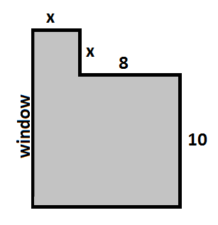
- Give the length of the window wall in terms of x.

_______________________________________

- Write an expression for the total length of skirting board to be used.

_______________________________________

_______________________________________

- If the total skirting board is 44 m, calculate the size of the walls marked x.

_______________________________________

_______________________________________

QUESTION NINE
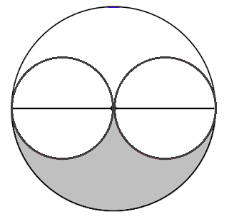
The formula for area of a circle is A= π r²

In this diagram, let the big circle have a radius of p. The smaller circles have a radius of ½ p.

- Write an expression for the shaded area in the diagram.

_______________________________________

_______________________________________

- If possible, simplify your expression from (a)

_______________________________________

_______________________________________

_______________________________________

- If the shaded area is actually 56 cm², calculate the radius of the large circle.

_______________________________________

_______________________________________

_______________________________________

_______________________________________

_______________________________________

_______________________________________

