NAME: | TEACHER:

YEAR 9 MATHEMATICS
2014 END OF YEAR EXAM

Statistics

QUESTION AND ANSWER BOOKLET

Answer ALL questions in the spaces provided in this booklet. Show ALL working.
Achievement For Assessor’s use only
Curriculum  Level 3 | Curriculum  Level 4 | Curriculum  Level 5

QUESTION ONE
Students in a PE class were asked to do as many press-ups and as many chin-ups as they could.
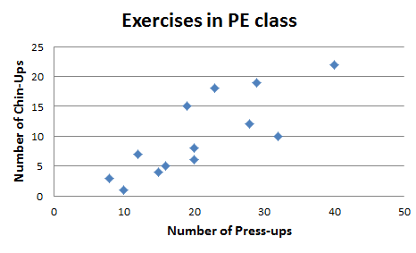
- What type of graph is this? What is it used for?

_______________________________________

_______________________________________

- Hand draw a line on the graph to show the general trend.

- Describe what the trend tells us about the situation: “students who can do more press-ups can...”

_______________________________________

_______________________________________

- Circle one point that is outside of the trend. Describe how this student’s skills are different from what you would expect.

_______________________________________

_______________________________________

_______________________________________

QUESTION TWO

Sally got a new cell phone. It keeps a track of how many text messages she sends in a day. The number of text messages she send each day for the first four weeks that she had her phone are shown here:
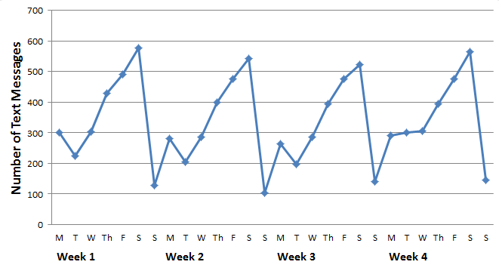

- On which day (and week) did she send the least messages?

_______________________________________

- Does Sally’s text message numbers seem to be generally increasing over time? Explain.

_______________________________________

_______________________________________

_______________________________________

_______________________________________

- Describe the pattern in Sally’s text message habits over a week.

_______________________________________

_______________________________________

_______________________________________
QUESTION THREE

A class of students was surveyed to find out how they usually watched movies that aren’t broadcast on TV. The results are shown in the graph below.
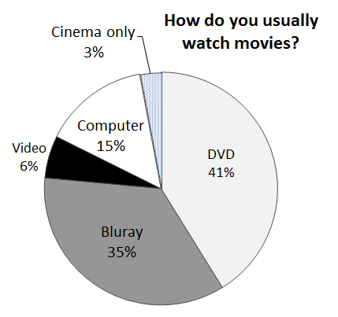

- What was the most common response?

_______________________________________

- If this was a group of 200 students, how many of them still used video?

_______________________________________

_______________________________________

- Calculate the angle for the “cinema only” section.

_______________________________________

_______________________________________

- Explain how the group of students should be selected so that they are a good sample of their school.

_______________________________________

_______________________________________

_______________________________________

_______________________________________
QUESTION FOUR
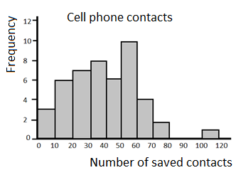A sample of adults was taken. They were asked how many contacts they have saved in their cellphone’s address book. The results are shown in the graph above.

- How many adults were sampled?

- Explain why it is not possible to say how many adults had 20 saved contacts.

- What is the mode group for number of saved contacts?

- Identify at least one other feature of the data’s distribution.

QUESTION FIVE

A sample of 20 Year 9 students was taken from Census at School

gender | Age of newest cell phone (in months)
boy | 16
boy | 3
girl | 48
girl | 48
girl | 24
girl | 12
girl | 24
boy | 8
girl | 5
boy | 5
boy | 13
girl | 2
girl | 9
girl | 12
girl | 29
boy | 6
girl | 6
boy | 20
girl | 3
boy | 9

- Does this sample seem reasonably representative of Year 9 students in general? Give reasons for your answer.

- Calculate the median age for boys’ cellphones and for girls’ cellphones. Does one gender tend to have older phones? Explain?

