INCONSISTENT EQUATIONS
Solutions do not exist  Equations are INCONSISTENT | 3 planes parallel | 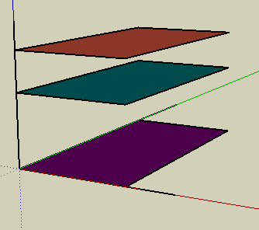
 | 2 planes parallel | 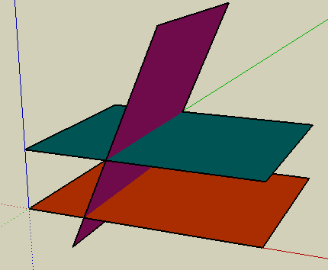
 | Lines of intersection parallel | 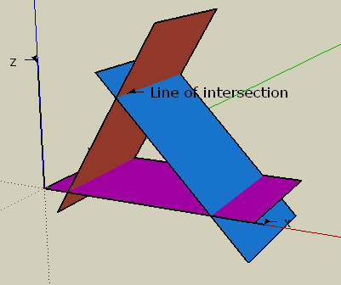

3 planes, 3 inconsistent equations
Equations cannot be solved
ALL 3 PLANES ARE PARALLEL
x + 2y + 3z = 10 (1)  3x + 6y + 9z = 4 (2)  4x + 8y + 12z = 7 (3)  Equations coefficients are  multiples of each others  (constant term does not)  3 x Eqn(1) = Eqn(2)  4 x Eqn(1) = Eqn(3)  Constants don't multiply | 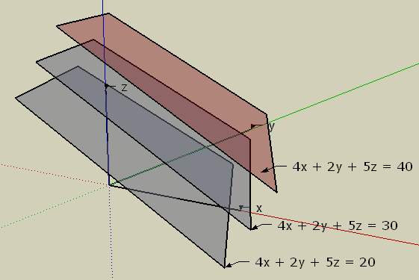

2 PLANES ARE PARALLEL
x + 2y + 3z = 10 (1)  3x + 6y + 9z = 4 (2)  3x + y + 2z = 6 (3)  Two equations have coefficients are multiples of each others  (constant term does not)  3 x Eqn (1) = Eqn (2) so they are parallel  Constants don't multiply | 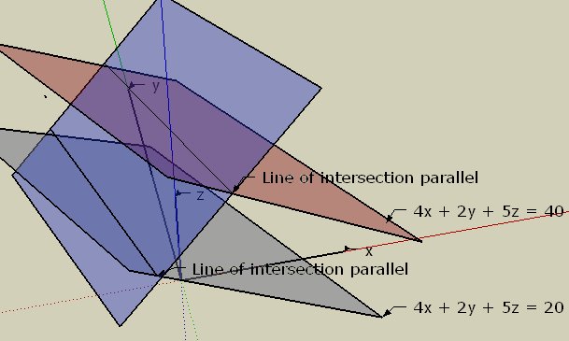

PARALLEL LINES OF INTERSECTION

x + 2y + 3z = 10 (1)
2x + 3y + 2z = 4 (2)
4x + 7y + 8z = 7 (3)

Two Equations have coefficients which can be scaled and combined to produce the third equation (constant term does not)
2 x Eqn (1) + Eqn (2) = Eqn(3)
Constants don't multiply

Note the similarity between these two situations
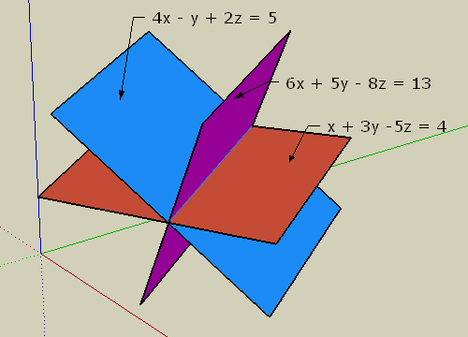
Equations can be solved  A LINE of solutions  Dependent Equations  Solving the equation results in something like 0 = 0 which is always true so there is infinite solutions  x + 2y + 3z = 10 (1)  2x + 3y + 2z = 4 (2)  4x + 7y + 8z = 24 (3)  Two Equations can be scaled and combined to produce the third equation  2 x Eqn (1) + Eqn (2) = Eqn(3)  Constants DO multiply | Equations can NOT be solved  No solutions  Inconsistent Equations  Solving the equation results in something like 0 = 3 which is never true so there is no solutions  x + 2y + 3z = 10 (1)  2x + 3y + 2z = 4 (2)  4x + 7y + 8z = 7 (3)  Two Equations have coefficients which can be scaled and combined to produce the third equation (constant term does not)  2 x Eqn (1) + Eqn (2) = Eqn(3)  Constants don't multiply
Changing the constant term in equation (3) changes the planes position (still being parallel)

