NAME: | TEACHER:

YEAR 10 MATHEMATICS
2014 END OF YEAR EXAM

Trigonometry

Answer ALL questions in the spaces provided in this booklet. Show ALL working.
For Assessor’s use only
Curriculum Level

==========================================================================
SKILLS QUESTIONS

QUESTION ONE
Use your calculator to give values for the following:

  - tan 89º = _________________
  - cos 14.5º = _________________
  - sin⁻¹ 0.27 = _________________
  - tan⁻¹(5÷7) = _________________
QUESTION TWO
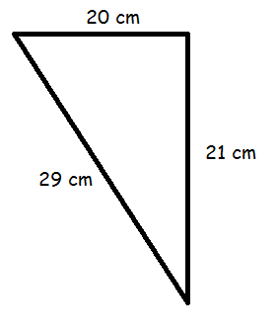
In a right-angled triangle, the sides have the following relationship (Pythagoras’ rule).
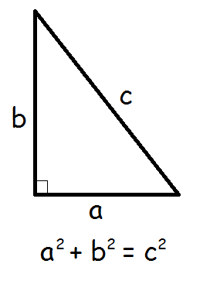
The following triangles are not drawn to scale. Use Pythagoras’ rule to work out whether each one is a right-angle triangle.
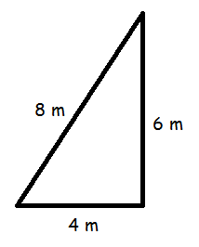
(a) Working:

Right angled? _____________

(b) Working:

Right angled? _____________

QUESTION THREE
- The Transamerican Pyramid in San Francisco has a slant height of 225 m and inclines at an angle of 78º. Calculate x, the height of the building.

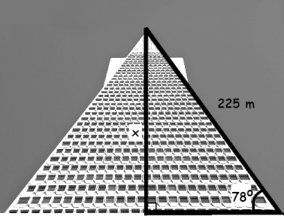

_______________________________________

_______________________________________

_______________________________________

_______________________________________

- The height and half-width of the Eiffel Tower in France are given below.
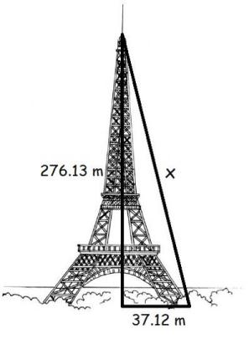
- If a cable (x) was run from the top to the base of the tower, calculate how long it would be.
_______________________________________

_______________________________________

_______________________________________

_______________________________________
- If the cable was attached to the base with an angle of elevation of 76º instead, how high up the tower (x) could it reach?
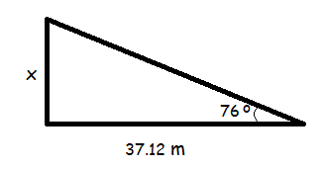
_______________________________________

_______________________________________

_______________________________________

- The “London Eye” is a giant Ferris wheel. Its support legs form an isosceles triangle with the ground. The legs are 58 m long and are 20 m apart at the base.
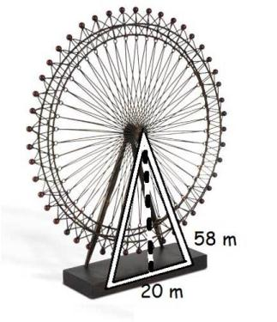
- Calculate the height of the hub of the wheel (the length of the dotted line in the diagram).

_______________________________________

_______________________________________

_______________________________________

(ii) Calculate the angle that each leg makes with the ground.

_______________________________________

_______________________________________

_______________________________________

- 5th Avenue, East 23rd St and Broadway in New York city nearly form a right angled triangle.
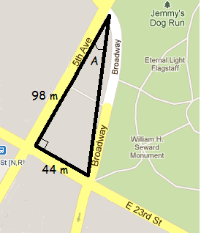
If Broadway didn’t curve, what angle (A) would it form with 5th Avenue?

_______________________________________

_______________________________________

_______________________________________

QUESTION FOUR
The famous “Leaning Tower of Pisa” inclines 4 degrees and is 56.7 m above the ground at the highest point.

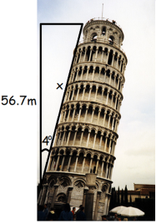

- How high (x) would it stand if it wasn’t leaning?
_______________________________________

_______________________________________

_______________________________________
- The tower leans less than it used to due to structural repairs. It used to have an incline of 5.5 degrees. Use your answer to part (a) to calculate the previous height of the highest point of the tower.

_______________________________________

_______________________________________

_______________________________________

_______________________________________

Please see next page

QUESTION FIVE

- The glass pyramid at the Louvre is surrounded by fountains and three smaller pyramids. The pyramid has a square base. The large pyramid and ponds together form ¾ of a large square. The lines connecting the three mini-pyramids (shaded) also form part of a square. These squares sit inside each other, forming 45 degree angles.
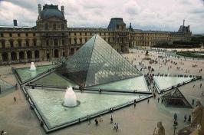
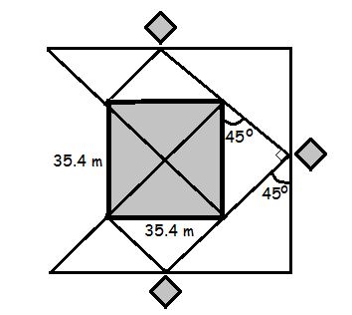
Calculate:
- the distance between the mini-pyramids (ii) the side length of the largest (incomplete) square.

____________________________________

____________________________________

____________________________________

____________________________________

____________________________________

____________________________________

____________________________________

____________________________________

____________________________________

____________________________________

- The Mayan temple of Kukulcan is nearly a square-based pyramid in shape. Calculate the height it would be if came to a peak (as in the diagram below.)




















