Year 9 EOY Exam 2014 NUMBER
Level 3 | Level 4 | Level 5
6 opportunities. Suggested grading:  2 = 3B, 4 = 3P, 6 = 3A. Work at Level 4 can count towards Level 3 if needed. | 7 opportunities. Suggested grading:  2 = 4B, 4 = 4P, 6 = 4A. Work at Level 5 can count towards Level 4 if needed. | 6 opportunities. Suggested grading:  2 = 5B, 3 = 5P, 5 = 5A.
1a 0.56  1c 56/100 (not simplified or simplified incorrectly)  2 110, 5, 1015 (all 3 or correct final answer).  3 3.4, 4.3, 4.33, 4.4, 13.35, 13.4  6a 1/4 of 48 = 12  6b 1/3 of 36 = 12 She loses 12.  P = 2  A = 4 | 1b 56%  1c 56/100 = 14/25 (simplified answer only okay)  4 Calculates distance from first to last hurdle (82.26 m).  5a ⁻7ºC  5b 24 ºC  6b She loses 12, had 36 (+ 4), ends up with 28 marbles.  8B Finds discount on bike (30% of 1300 = $390)  M = 5 | 4 Distance from first to last hurdle is 82.26 m. Ten hurdles have 9 gaps between them. Therefore, spacing is 82.26 / 9 = 9.14 m  6c She has 24 out of her 48 original marbles (50%) OR accept she has 28 marbles, had 48 = 28/48 = 58%  7 18/5.50 = 3.27 i.e saves for 4 weeks to have enough.  8A Takes 80 weeks (given). Total paid for bike is  15 x 80 + 200 = $1400  8B (1) Cost of bike will be $910  8B (2) Time to save is 61 weeks (51 weeks to pay off $760 to parents plus 10 weeks of saving). Students have shown adequate evidence if they calculate the weeks to pay back the parents and forget to add 10.  8B (3) Costs $1300 (given). Saving is now 16.50 per week. Takes 79 weeks (nearest week)  E = 5

Year 9 EOY Exam 2014 ALGEBRA
Level 3 | Level 4 | Level 5
7 opportunities. Suggested grading:  2 = 3B, 4 = 3P, 6 = 3A. Work at Level 4 can count towards Level 3 if needed. | 18 opportunities. Suggested grading:  6 = 4B, 10 = 4P, 14 = 4A. Work at Level 5 can count towards Level 4 if needed. | 8 opportunities. Suggested grading:  2 = 5B, 4 = 5P, 6 = 5A.
1a At least 2 different pairs of numbers suggested.  2a 5  2b n = 6  5a 4f  5b 5y  5fi 2n  10a 4(x + y)  P = 3  A = 5 | 1b Yes – it is okay for x and y to be the same.  1c Writes at least 2 value equations using the variables p and q, remaining true to their stated values.  2c 4  2d n = 4  3 Suggests one solution e.g. 12 loaves of bread.  4a e.g. 52 – 1.5n = 10  5c 8n + 3  5d p³  6a n + 1 + 4 + n + 1 + 4 = 2n + 10  6b 4(n + 1) = 4n + 4  7a 4p + 8  7b n² – n  8a -2x² + 10x  8b 2x – 8  8c 5a² + 6a  M = 10  8d -16 + 3x  10c p(4 + p)  9a $8  9b He will have to pay $2 to his aunt! (-$2) | 2e n = 3  3 Suggests more than one solution including at least one that uses different items e.g. 6 bottles of milk and 3 loaves of bread  (bottle of milk = 3 eggs, loaf = 2 eggs, apple = ½ egg)  4 (Writes correct equation AND solves 4b  n = 28 minutes).  7e -n + 4 or 4 – n  5fii 5(n-1) or equivalent.  7c 3p – 15 + p² + 8p = p² + 11p – 15  9c 5 times  E = 4

Year 9 EOY Exam 2014 STATISTICS
Level 3 | Level 4 | Level 5
4 opportunities. Suggested grading:  1 = 3B, 3 = 3P, 4 = 3A. Work at Level 4 can count towards Level 3 if needed. | 10 opportunities. Suggested grading:  3 = 4B, 6= 4P, 8 = 4A. Work at Level 5 can count towards Level 4 if needed. | 6 opportunities. Suggested grading:  2 = 5B, 3 = 5P, 5 = 5A.
1a Scatter plot  2a Sunday, end of Week 2  3a DVD  4c 50-60  P = 2  A = 3 | 1a Looking for relationships between two variables  1b Line fitted by eye, follows general shape of the points.  1c “Also do more chin-ups”  1d Circles the point at (32, 10) and states that it is below the trend line.  2b No, overall trend is fairly flat. Maybe even slightly descending.  3b 12  3c 10.8 degrees.  4a 47 +/- 2 (by summing bar heights.)  4d Any feature e.g. outlier at/above 100, single peak…  5b Either median: Boys’ is 8.5, Girls’ is 12  M = 7 | 1d Circles the point at (32, 10) and interprets e.g. can do less chin-ups than you would expect, given the number of press-ups they can do.  2c A detailed description e.g. dips after Monday, slowly climbs until Saturday and then a big drop to the minimum at Sunday.  3d Describes a method that either refers to unbiased selection or ensuring a representative sample in some aspect.  4b The histogram gives intervals rather than whole numbers. The bar than includes 20 also includes other numbers.  5a Justified answer e.g. “Yes – 8/20 are male, that is not too far from half” e.g. “No , the sample should be half male and half female but there is only 40% male”.  5b Calculates the 2 medians. Girls’ is 12, Boys’ is 8.5 and comments that the Girls seem to have older phones. A mention of the fact that this is sample data and only gives an estimate is desirable.  E = 4

Year 9 EOY Exam 2014 TRANSFORMATIONS
Level 3 | Level 4 | Level 5
5 opportunities. Suggested grading:  2 = 3B, 3 = 3P, 4 = 3A. Work at Level 4 can count towards Level 3 if needed. | 10 opportunities. Suggested grading:  3 = 4B, 6= 4P, 8 = 4A. Work at Level 5 can count towards Level 4 if needed. | 5 opportunities. Suggested grading:  1 = 5B, 2 = 5P, 3 = 5A.
1b D  1c CD  1d DCF or FCD  2a  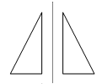  P = 2  A = 3  4a 2 (more than 1 and less than 3) | 1a F and C  2b 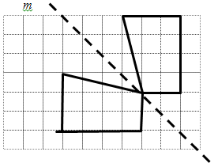  3a 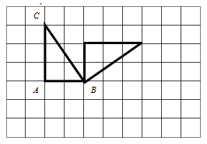  3b 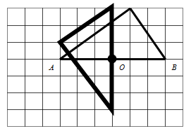  5 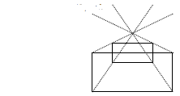  6 a b c d  6 e f  M = 7 | 7  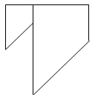  8  - 1 1 2  - 5 5 10  - 4 4 8  9  Accept any 2 clear logical explanations of transformations which exist. Shapes must be CLEARLY explained as well as method of transformation.  E = 3  E = 4

